How to get the book for this course
The book for this course is Murach’s Modern JavaScript by Mary Delameter.
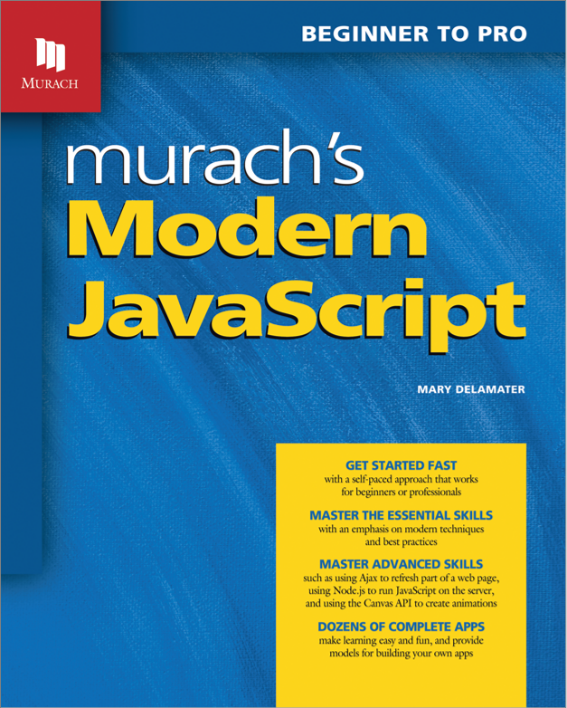
Print ISBN: 978-1-943873-14-2
eBook ISBN: 9781943873159
If the eBook is included in the course materials provided to you, your instructor will give you the details on accessing it. Otherwise, you can get this book or eBook from the following websites:

Print book or eBook
Murach Books
Print book and eBook may also be available from
Barnes & Noble college bookstore
Follett college bookstore

eBook only
VitalSource
RedShelf

Print book only
Amazon

International sources
Canada: Texidium for eBooks; follow your instructor’s instructions for access
UK: Gazelle Book Services Ltd. for print books
Australia and New Zealand: WoodsLane Pty. Ltd. for print books
For additional options: Please visit Murach Books

